SEBI REGULATIONS – SEMANTIC ANALYSIS

OBJECTIVE:
To identify the characteristics of the semantically clustered regulationed for potential tags for the semantic layer in bitvector retrieval. The tags will be represented as bits.

Tags/Sub-tags identified (sources: SEBI, glossary, legal dictionary):
- Finance
- Accounting
- Capital Market
- Commodities Market
- Pension Funds

PIPELINE:

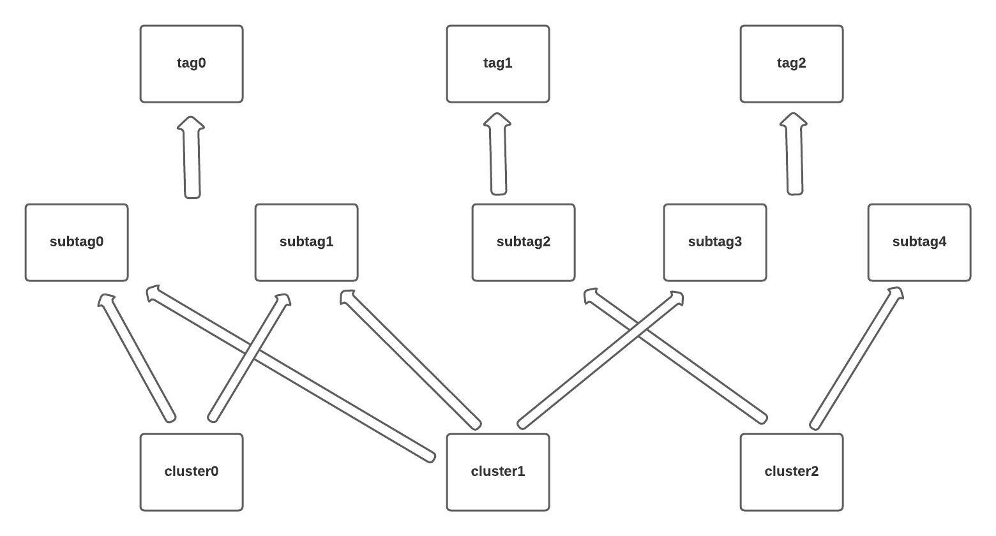

PROPOSED METHODOLOGY:

1. Preprocessing of data

- Input: Regulations in SEBI database
- Output: Subject tokens

2. Pre-trained embedding (legal domain)

- Law2Vec – Open source Legal word embeddings (123,066 documents)
- 100-dim vectors
- Reguations vector values – average of vector values of terms in the regulation

3. Spectral Clustering

- Graph constructed using pre-trained embedding values (nodes - regulations)
- Project to low-dimensional space – eigen values and vectors using graph laplacian
- K-means to cluster (number of clusters=3 by elbow method)

Why Spectral Clustering?

- Results are better for small datasets
- Dimensionality reduction of vectors – good clustering results

OBSERVATIONS:

Clusterwise distribution of tag words.

- Within cluster – Percentage of frequency of tag terms within the cluster
- Global frequency – Percentage of frequency of tag terms in the cluster with respect to their total frequency in the database (Importance measure)

Tags | Percentage Analysis Metric | Clusters (0,1,2) - Value (in %)
Finance | Within cluster | 8.39  10.23  3.91
 | Global frequency | 92.72  6.62  5.12
Accounting | Within cluster | 11.42  2.48  32.5
 | Global frequency | 92.71  2.36  12.38
Capital Market | Within cluster | 22.41  12.91  38.75
 | Global frequency | 90.2  3.66  13
Commodities Market | Within cluster | 1.82  0.52  0
 | Global frequency | 96.3  1.02  0
Pension Funds | Within cluster | 0.75  1.55  0
 | Global frequency | 94.09  5.83  0

- Cluster 0 – high percentage of all tag terms.
- Nested K-means – Cluster 0 (3 clusters)

Tags | Percentage Analysis Metric | Clusters (0,1,2) - Value (in %)
Finance | Within cluster | 12.48  5.04  28.55
 | Global frequency | 41.33  44.16  29.33
Accounting | Within cluster | 13.16  10.16  17.98
 | Global frequency | 34.08  57.41  28.92
Capital Market | Within cluster | 30.91  15.7  62.46
 | Global frequency | 42.91  49.78  21.49
Commodities Market | Within cluster | 1.82  1.96  0.32
 | Global frequency | 28.31  71.03  0.51
Pension Funds | Within cluster | 0.8  0.66  1.26
 | Global frequency | 44.55  43.47  19.32

Next Steps:

- Unequal cluster size – alternative clustering methods
- Alternative embedding techniques – comparison
- Other possible tags
- Other ways of capturing semantics (Eg. N-grams)

